Lightweight Design for automotive structures in 3D printing

Abstract:
The project aims to develop and implement an advanced tool that allows semi-automatic modelling of structures with high complexity and large size designed for 3D printing. The aim of the research project is to solve non-trivial design problems through the help of software that optimizes the design intent both from the point of view of weight and from the point of view of the shape by providing an automatic split of the structure that allows the production of the same through the modern and already consolidated technologies of rapid prototyping (3D printing or Additive Manufacturing). In addition, printing multiple material types in a single printer, presents added challenges that must be addressed. An other target of the research program is to implement an innovative additive manufacturing process, in which a fiber and a matrix material are simultaneously deposited creating a sort of Fiber Encapsulation Additive Manufacturing (FEAM).
With the help of these new methods, the end user will therefore have to devote himself only to the design of the functional parts considering only the design constraints of the system, but without having to worry about the different manufacturing technologies and how design for manufacturing.

State of art:
Often the product development process goes through a creative phase in which there are very clear tasks that must be carried out by the component, but the shape that the whole part must have to reach the objectives is not yet outlined. So far, we have been used to designing according to a Boolean vision, supported by subtractive production technologies or by forging, injection moulding, or casting techniques. 3D printing has overturned these "rules", giving designers the opportunity to create completely new geometries and in many cases impossible to produce with "past" technologies. Additive manufacturing is a technology rapidly expanding on a number of industrial sectors. It provides design freedom and environmental/ecological advantages. It transforms essentially design files to fully functional products [1, 2]. We are convinced that the spread of additive manufacturing systems in the industrial sector will maximize the potential of topological optimization. Topological optimization is based on an algorithm capable of eliminating redundant elements within a finished element, based on assigned load criteria and geometric constraints. A mathematical model at the service of a new distribution of the masses, for the creation of lighter and more performing models. On the one hand, the designer knows what the interfaces are with the other parts, has more or less realistic and sensible estimates of the loads that weigh on the system, and the desired mechanical performances are defined by quantifying, for example, stiffness, strength, weight of the product based on experience or benchmarks with other own products or competitors. On the other hand we have ideas on the manufacturing technologies of the product: electro-welded carpentry, machining, casting, injection, or even 3D printing. In the middle we have the white sheet, or rather a project space contained inside of the volume that envelops the interfaces with the rest of the world and within which we want to find a distribution of material that not only guarantees the desired performance, but which is also economically feasible. Topological optimization is a computer simulation technique in which it is possible to bring together the essential characteristics of the project in terms of project volume, production technology, loads, operating conditions and objectives to be achieved, which allows to synthesize an innovative form for the product, identifying those areas of the volume necessary to achieve the target, and removing all the others [3].
The latest research also shows that even assemblies made of several components or with different loads can be successfully integrated and improved using topology optimization [4,5].
Topological optimization proves to be an ideal tool in the conceptual phase of the design process that allows you to quickly get to fairly coarse conceptual form proposals, therefore requiring a refinement of construction details, but which in any case allows you to drastically reduce the many design iterations and, at the same time, provides valuable indications to the designer on how to improve the product design.
The beauty of topologic optimization is that it can be applied in practically any structural context to determine, for example, the best distribution of material for the base of a machine tool made by casting, or the crosspiece of a press that must be very rigid, or to improve the shape of the moving parts that must be rigid and light at the same time.
The first paper on topology optimization was published over a century ago by the versatile Australian inventor Michelle (1904) who derived optimality criteria for the least weight layout of trusses. Starting with the landmark paper of Bendsøe and Kikuchi (1988) that has presented most popular numerical FE-based topology optimization method called SIMP method. Ole Sigmund (2001) developed a Matlab code for topology optimization based on minimizing compliance, mainly using optimality criteria approach that depends on the sensitivity of the objective function [6]. Also there are some methods that can be considered as numerical methods such as, sequential linear programming (SLP), sequential quadratic programming (SQP), and method of moving asymptotes (MMA) by Krister Svanberg [7] that can be used for topology optimization.

Project Description:
Target:
The main target of the research project is to develop a surrogate-based optimization tool able to combine one or more commercial CAE software in order to be able to manage complex and large size structures, with the focus on lightweight design for 3D printer.
Topology optimization starts from a continuous model of the design space. Iteratively, the optimization process removes, or re-distributes the material from the design space that is not being used efficiently. The optimization process continues by removing the material up to the predefined volume fraction in the design space and stops. Figure 1 illustrates the flow diagram of the Topological Optimization, with a schematic representation of how the FEM model is interpreted in the various phases. The result of this analysis is provided by the optimal distribution of the material for the application provided. A difference in the manual design iterations inspired by the designer's experience and intuition, Topological Optimization can sometimes lead to very surprising designs.
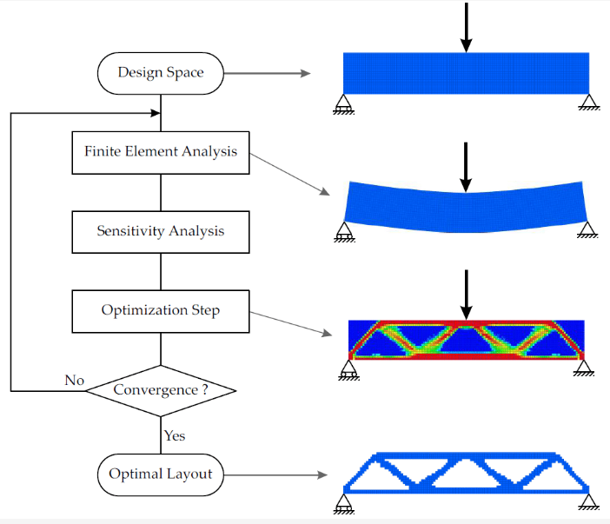
Figura 1- Flow diagram of the Topological Optimization
The SIMP (Solid Isotropic Material with Penalisation) approach connects a relative element density function to each active element of the project space. The relative density of the elements is a real function that can represent a value between 0 and 1. Multiplying the stiffness matrix and the mass of active elements with the relative density value, it is a stiffness and mass distribution with continuity.
Using the element densities as an optimization parameter, Topological Optimization is transformed into continuous optimization. The main disadvantage of using the relative element density function is that the final layout it obtains is not necessarily a 0-1 design, but element areas that have a relative density with an intermediate value could be obtained. These distributions are difficult to interpret physically, and intermediate densities in the final layout are usually avoided.
To guide the layout towards a 0-1 type design, the SIMP algorithm uses an exponential penalty factor p> 1 to make intermediate density values ​​less favourable as the stiffness they produce is small compared to the cost (volume of material). This approach is usually called an implied penalty. To obtain a 0-1 drawing, we usually take p> 3.
The topology SIMP methods, optimizes the design variable which is the elemental densities in a design domain that would minimize the volume of the final structure while satisfying the stress constraints and displacement constraints. The objective function and constraints can be mathematically expressed as follows [8]:

$$\left\{\begin{aligned}Findρ={\left(ρ_{1},ρ_{2},…,ρ_{n}\right)}^{T} \\ MinV=\sum_{i=1}^{n}{ρ_{i}v_{i}} \\ S.t.∧∧∧∧∧∧\left\{\begin{aligned}F=Ku \\ u≤u^{} \\ σ≤σ^{} \\ 0≤ρ_{min}≤ρ_{i}≤ρ_{max}\end{aligned}\right.\end{aligned}\right.$$

where $ρ$ is the design variable, V is the volume of the structure, F is the load vector, K is the global stiffness matrix, u is the global displacement vector, u* is the displacement constraint, $σ$ is the von Mises stress vector, $σ^{}$ is the stress constraint. Employing the solid isotropic material with penalization [9-11] method, the problem is relaxed for density to have any value between 0 and 1 with small lower bound of $ρ_{min}=0.001$ to avoid singularities when calculating for equilibrium. Also, as wrote above, with penalization power parameter (p) that is greater than 1 (generally, p =3.) , the intermediate density values are steered to either extreme and Young’s modulus of each element is computed as follows:

$$E_{i}={ρ_{i}}^{p}E^{0}$$

Where $E^{0}$ is the Young’s moduls of the material in the solid state ( $ρ=1$ ). When p changes, the relationship between E and relative density $ρ$ is shown in Figure 2.

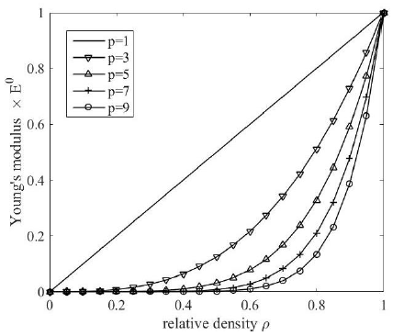
Figure 2- The relationship between E and relative density ρ with p in SIMP method
Not only static constraints are requested for the main mechanical structures as topology SIMP algorithm take into account, but also dynamic play an important role in a complex design problem. It will need to integrate the SIMP algorithm taking into account of dynamic behaviour of the structures. In this case, optimization based on vibration and stiffness requirements is needed [12].
An other issue to solve when it comes non-trivial design is “how” to print complex and large size structures in 3D printing technologies; in the present research project we will implement additional objective functions such that the new maximum printable dimension constraints has to be took into account. Then, together with the requirements for tolerances, the restrictions from the manufacturing process and the post processing options, the code should be able to evaluate the manufacturability of the proposed design. If the analysis shows that the part is not additive manufacturable, it is possible to redesign the shape in a semi-automatic and mathematically assisted way by split the complex structure in more parts manufacturable with 3D technologies. In Figure 3, a first concept idea of the proposed method.
Figura 3 - Proposed method - concept idea
NO
YES
NO
YES
Geometry of the concept
Requirements for tolerances
Restriction of AM
Restriction of post processing
Developing a concept with ideal shape
Functions and requirements
Is the concept optimized for
3D Printing?
Topology Optimization
(SIMP, MMA, PARETO …)
Structure splitting in 3D printable sub-parts

Assembly of sub-parts proposals are ok?

Other restrictions for manufacturing could be, for example, the output quantities, specific materials, multi-materials or their certification. As a result, a realizable figure emerges with the aid of the restrictions. Further, can be implemented constraints such that printable sub-parts have to be symmetric, equal or similar where possible, simplifying the production process and reducing the manufacturing costs.
With respect to efficiency, the focus here must always be on the branch concerned. For this, assessments must be made regarding the price sensitivity to be able to draw conclusions about the needs of the market. In order to ascertain how exactly the costs and the weight are related, the functions of the material costs, the production costs and the development costs should be established depending on the weight. This results in the total cost function in which the minimum can find the optimal solution and thereby the best compromise of costs and weight. Some branches, however, can generate entirely other uses with lightweight construction and therefore also react more tolerantly to additional costs that could arise with lightweight construction. In the aerospace industry, a kilogram of weight saved has an average equivalent value of € 5000. In aviation, it is at least € 500 on average and in automotive construction only € 7. Thus, it is essentially vital to identify the customer needs prior to development [13].
At the end, in order to have a complete picture, has to be considered also the time needs for manufacturing. Additive manufacturing technologies are opening new opportunities in terms of production paradigm and manufacturing possibilities. Manufacturing lead times will be reduced substantially, new designs will have shorter time to market, and customer demand will be met more quickly.

Project Steps:
In the first step of the project will be conducted a deep research and analysis of the most recent topological optimization method for lightweight design. In this phase will be also needed the knowledge of the modern 3D printing technologies with particular reference to the Additive manufacturing and a deep learn of the program languages suitable for the application, like Matlab, C++, Python and the graphic library for the visualization.
In the second step, the purposed code will be write both stand-alone format both for CAD integration as FreeCAD [14] or Blender [15].
Once the method, model and code will be available, a validation tests campaign and verifies are expected in order to evaluate the correctness, the robustness and flexibilities of the code.

Software tools:
The deep knowledge of program languages like C++ and Phyton allow to be aligned with modern technologies. It will be also important the detailed knowledge of commercial CAE software and FreeCAD for the code integration.

Test and validation:
In order to support a real industrial design environment with a such described tool will need to verify the computational costs in order to reduce costs and time for design and also verify the robustness of the implemented method.

Expected results:
The purpose of the project is to integrate and create 3D CAD model technologies in order to define an advanced and semi-automatic tool for 3D printing. Thanks to this innovative method the final user during the design of complex and not trivial design, will be assisted from the calculator in terms of lightweight optimization and in 3D printing feasibility. With these simplifications, industries can save time and cost because the designer won’t need to think how optimize the project and won’t need to think how design for 3D printing because the software will assist for that. The method can be also considered useful in terms industrialization process for modern manufacturing technologies thanks to the desired modularity of the sub-parts and allow to enlarge the domain of 3D printable structures.

